Using the iParent Portal.

The iParent Portal allows parents to view their child’s grades and progress through out the school year. To sign up for access you will need your child’s 4 digit student id number. This should be on the paperwork sent home with your child at the beginning of the school year. If you do not have it, please contact the office at your child’s school.

To register with iPass you can go to the District website (www.douglasps.net) Click on the Section that says Parents Page and Click on iPass/IParent Portal. When the iPass homepage opens, under News you will see it says “Click here to apply for on-line access to your child”
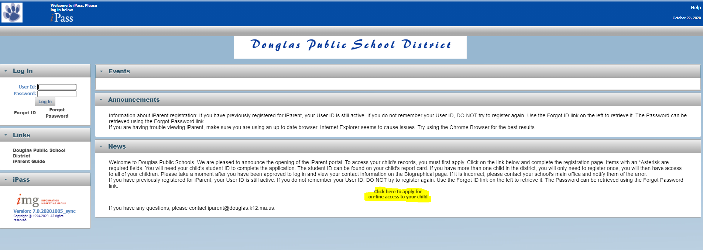
If you click on that it will take you to the registration page. This is where you will enter the information to register for access to your child.
There is a drop down to choose the number of students you are registering. You should do them all at once, you do not register each separately. It will add information boxes for you to fill out for the number of children you choose here.
The first box is personal information. That is your Name and email. When you get down to the box that says “Internet user information” The first box is User ID. This is the ID you want to use for logging in. Not the student ID number. Then enter the password you wish to use.

The next box is Primary Student information. This is where you enter the 4 digit student ID.
When you have entered all the required information hit the submit button at the bottom of the page.
Your registration will need to be reviewed and approved by our staff. You will not have access immediately.
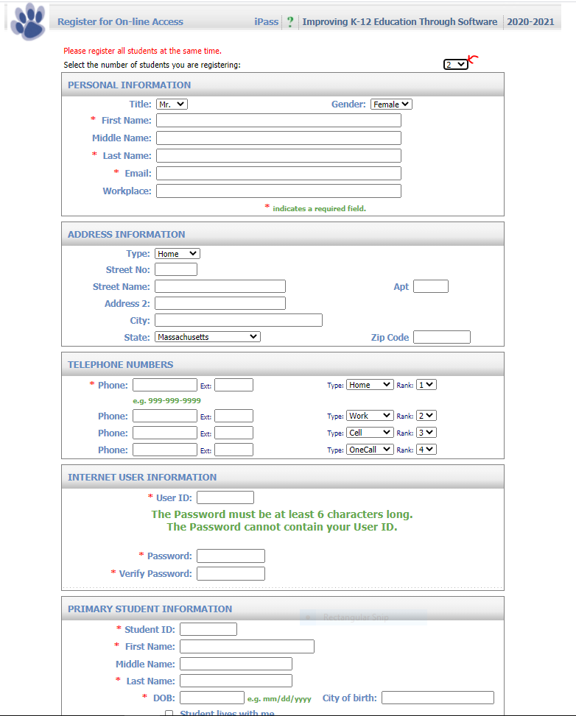

The iParent system is designed to provide an additional option for the sharing of information between Parents, Teachers, Students, and Administrators. It is NOT meant to be a replacement or substitute for telephone conversations, parent/teacher meetings, or any other direct interaction with the school system.

Note: In the following section each possible menu option is explained. Each School in your school district has the ability to show or not show each option. When you access the iParent folder you may not see all of these options.

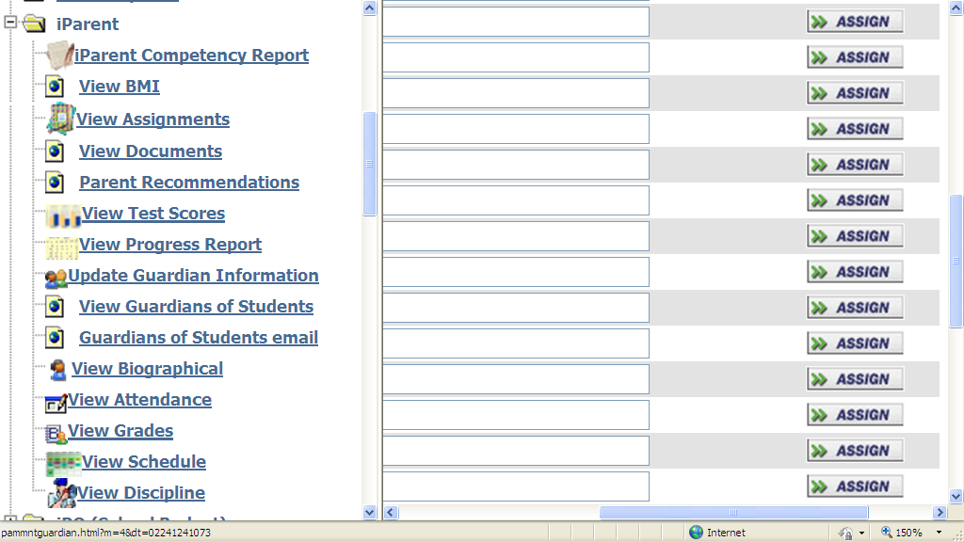

This screen shows your child’s standards based or competency based report card. The screen will contain multiple tabs for subject areas that have competencies associated with them and the scores and narratives entered by your child’s teachers.

This screen shows your child’s homework/assignments by course. It also indicates your child’s schedule, including teacher’s name and the course and section number.

Homework Assignments for the next (xx) days: This allows you to select homework assignments for the next 7, 14, or 21 days, based on the due date of the assignment.

It is possible for a student to have a homework assignment that is not reflected in this display. Parents are encouraged to contact their child’s teacher, counselor, and/or administrator to further verify homework assignments. Not all teachers choose to participate in posting assignments.

Show All: Clicking on “show all” will display all of the homework assignments associated with a particular course.

Assignment Date: This is the date that the homework assignment was issued. Clicking on the “assignment date” will sort homework assignments by assignment date.

Due Date: This is the date that the homework assignment is expected to be turned-in to the teacher. Clicking on the “due date” will sort homework assignments by due date.

Title: This is the teacher’s short description of the homework assignment. Clicking on the Title’s description line will open another window showing additional information about the homework assignment.

Details: Displays the first line of the homework assignment details, which can be seen in full by clicking on the Title’s description line as indicated above.

The envelope image indicates that email communication is available with the particular teacher. Clicking on the envelope will open an e-mail form allowing parents direct email communication with the specific teacher.



This screen allows parents to view course recommendations for the following year that have been entered by your child’s teachers in several subject areas. You may approve, not approve or enter your own recommendations for your child. Please view the iParent Online Course Recommendations Quick Start Guide for additional information and details.

This screen shows your child’s Standard Test Scores that are maintained in iPass. Examples of these would be MCAS scores and SAT scores.

This screen shows your child’s Progress Reports by course.

This screen shows your child’s year-to-date daily attendance summary activity for the current school year.

From: dd/mm/yyyy To: dd/mm/yyyy: This is the first day of school to the present day of school. Showing the year-to-date daily attendance summary information on your child.

Present: The total number of days your child has been present since the first day of school.

Absent: The total number of days your child has been absent since the first day of school.

Tardy/Present: The total number of days your child has been tardy/present since the first day of school. A child is marked tardy/present if they are late for school but arrive before the school’s specified time for being considered and recorded as absent for the day.

Tardy/Absent: The total number of days your child has been tardy/absent since the first day of school. A child is marked tardy/absent if they arrive to school after the school’s specified time for being considered present for the day.

Dismissed/Present: The total number of days your child has been dismissed/present since the first day of school. A child is marked dismissed/present if they are dismissed from school after the school’s specified time for being considered present for the day.

Dismissed/Absent: The total number of days your child has been dismissed/absent since the first day of school. A child is marked dismissed/absent if they are dismissed from school before the school’s specified time for being considered and marked absent for the day.

Tardy/Dismissed/Present: The total number of days your child has been tardy/dismissed/present since the first day of school. A child is marked tardy/dismissed/present if they arrive to school late and are dismissed early, but have been present in school fro more than half of the school day.

Tardy/Dismissed/Absent: The total number of days your child has been tardy/dismissed/absent since the first day of school. . A child is marked tardy/dismissed/absent if they arrive to school late and are dismissed early and have been absent from school for more than half of the school day.

Inside Suspension: The total number of days your child has been given an inside suspension since the first day of school.

Outside Suspension: The total number of days your child has been given an outside suspension since the first day of school.

This screen shows your child’s year-to-date daily attendance detailed information for the current school year. The Date, Day, Description, and related Times of the attendance record are shown.

This screen shows the courses in your child’s current schedule and the corresponding term grades (i.e. report card grades) to date. Grades can be represented alphabetically and/or numerically.

Comment/Click for Details: This will display the effort and conduct evaluations, class absences and comments, for each marking period, as entered by the teacher. “Absent” is the number of times a student has been absent from the course during each marking period.

Honor Roll Status: This is the student’s honor roll status by marking period. Please refer to the <school definition> for specific coding.

Previous Earned Credits: This is the total number of credits that the student has earned in the previous school year.

Total Credits: This is the total number of credits that the student has earned to date. Credits earned so far in the current school year plus accumulated credits earned in previous years.

Career GPA: This is the student’s career Grade Point Average

Career Rank: This is the student’s career rank and its relation to their respective grade level.

The envelope image indicates that e-mail communication is available with the particular teacher. Clicking on the envelope will open an e-mail form allowing parents direct e-mail communication with the teacher.

This screen shows your child’s existing schedule.

Select Term: This allows you to select a particular term of your child’s schedule. It defaults to the active term of the current school year. Simply click the combo box, highlight and select the term of choice.

Period: The periods of the school day and course meeting times are reflected in this column.

Day: The days of the school week are shown in this row.

Course: The grid displays the course/section number, an abbreviated title of the course, and the room location of the courses for the selected term.

The listing at the bottom displays all the courses that the student is enrolled in for the entire school year with course/section, term, name, room, teacher, schedule and potential earned credits for the course.

This screen shows your child’s existing Discipline records.

This message will show up if Discipline is not viewable at your child’s current school.

Discipline data is not published by this student's school.

